Dear Parents and Art Students,

Hooray!! It is almost time for art class! We are so excited to see you! Classes begin after Labor Day.

Fall Classes and The Art Show: Classes are one hour long. (Adult classes are 2 hours long.) Classes run through May and will conclude with an exhibit of each student’s work completed in class. In order to participate in the Art Show, students must be enrolled in May. The Art show is great fun and a wonderful experience for all! Returning students should pick up any art work left at this past Art Show or the SunTrust Art Show on the first day of class.

Mark Your Calendar! When Chesterfield County Public Schools are closed the ENTIRE DAY due to snow, Art Adventures will also be closed. Classes are not in session the week of Thanksgiving and a winter holiday to include Dec. 25 and New Years. The studio will also close for CCPS spring break. Art Adventures provides make up classes on an individual basis.

Fees: Monthly fees are due the first week of each month. You should have already paid the $45 family registration fee. May is the last month for the Fall billing cycle. Please make your checks payable to Art Adventures. You may bring your fee to Art class or mail it, care of Amy Barr, to 315 Enon Church Rd. Chester, VA 23836.

Supplies for returning students: Full payment is required to receive supplies. Please click HERE, download, print and fill out the supply form. Mail it to the address below. If the link will not work, please visit ArtAdventuresFUN.com. Click on ORDER SUPPLIES to download and print the correct form. Please note: RETURNING students rising to the 1st grade or 4th grade need to order a new (bigger) box to fit additional supplies.

Mailing Address for Art Adventures: 315 Enon Church Rd. Chester, VA 23836.
Supply orders received by August 24th should arrive by the second week of class. Don’t worry, students are welcome to borrow supplies in the meantime.

Policies: Tuition is non-refundable. Late payments are also subject to a fee. There is a $25 charge for returned checks. Students should arrive and be picked up in a timely manner from the Art room. Art Adventures is not responsible for students after class has ended. Private lessons and new classes are created upon request. Feel free to call us!

Feedback, ideas and suggestions: I am committed to providing a caring, creative and fun environment for everyone. The email info@artadaventuresfun is confidential. I invite you to drop a note anytime with feedback about your ideas, our program, staff or just to say “Hi”! I love hearing from you and want to do all I can to make Art Adventures a wonderful place. Thank you ALL, you are like family to me. Hugs to Everyone!

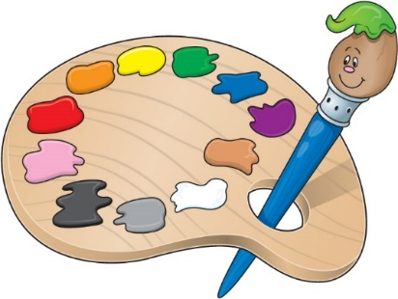
We can’t wait to see you!

Creatively,

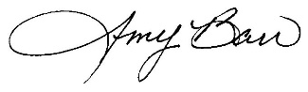Studio # 804-437-1104

